CBSE MANDATORY SCHOOL INFORMATION
1. URL Of the School Website: www.hpsramanthapur.org
2. Details of Curriculum: Central Board of Secondary Education (CBSE)
3. School Managing Committee Information:
MEMBERS OF THE MANAGING COMMITTEE OF THE HYDERABAD PUBLIC SCHOOL SOCIETY (REGD.) 2020-21
S.No. | Names of the Managing Committee Members |  |  | Designation
1 | MR. A. SHYAM MOHAN |  |  | President
2 | MR. GUSTI J NORIA |  |  | Vice President
3 | MR. M. A. FAIZ KHAN |  |  | Secretary & Treasurer
4 | MR. K. SOMNATH |  |  | Member
5 | MR. M. ADITHYA REDDY |  |  | Member
6 | MR. K. CHANDRA SHEKHAR REDDY |  |  | Member
7 | MR. G APPNENDER BABU |  |  | Member
BOARD OF GOVERNORS
S.No |  | Names of the Board Of Governors | Designation
1 |  | Smt. Chitra Ramachandran, I.A.S.  Special Chief Secertary to Government,  Education Department,  Govt. of Telangana | Chairman
2 |  | Sri. Gusti J Noria,  Vice President, HPS Society (Regd.) | Vice Chairman
3 |  | Sri. G. S. Ram Mohan Rao,  Additional Secretary to Govt.,  Finance Department,  Govt. of Telangana. | Member, BOG
4 |  | Smt. A. Sridevasena, I.A.S.  Director of School Education,  Govt of Telangana | Member, BOG
5 |  | Sri. M.A. Faiz Khan  Secretary & Treasurer, HPS Society (Regd.) | Member, BOG
6 |  | Sri. R. Raghuram Reddy,  Member, HPS Society (Regd.) | Member, BOG
7 |  | Mr. C. Parthasarathy  Member, HPS Society (Regd.) | Member, BOG
8 |  | Prof. B. R. Virmani  Member, HPS Society (Regd.) | Co-opted Member
9 |  | Mr. Skand Bali, Principal,  The Hyderabad Public School, Begumpet, Hyderabad | Member, BOG
10 |  | Dr. S Narasimha Reddy, Principal,  The Hyderabad Public School, Ramanthapur, Hyderabad | Member, BOG
11 |  | Sri. Arvind Kumar, IAS  Vice Chancellor (I/C),  Osmania University, Hyderabad | Member, BOG
12 |  | Sri. Jayesh Ranjan, IAS  Vice Chancellor (I/C),  JNTU, Hyderabad | Member, BOG
13 |  | Smt. M Radha Reddy,  Secretary to Board of Governors,  The Hyderabad Public Schools | Secretary

4. Transfer Certificate Sample:
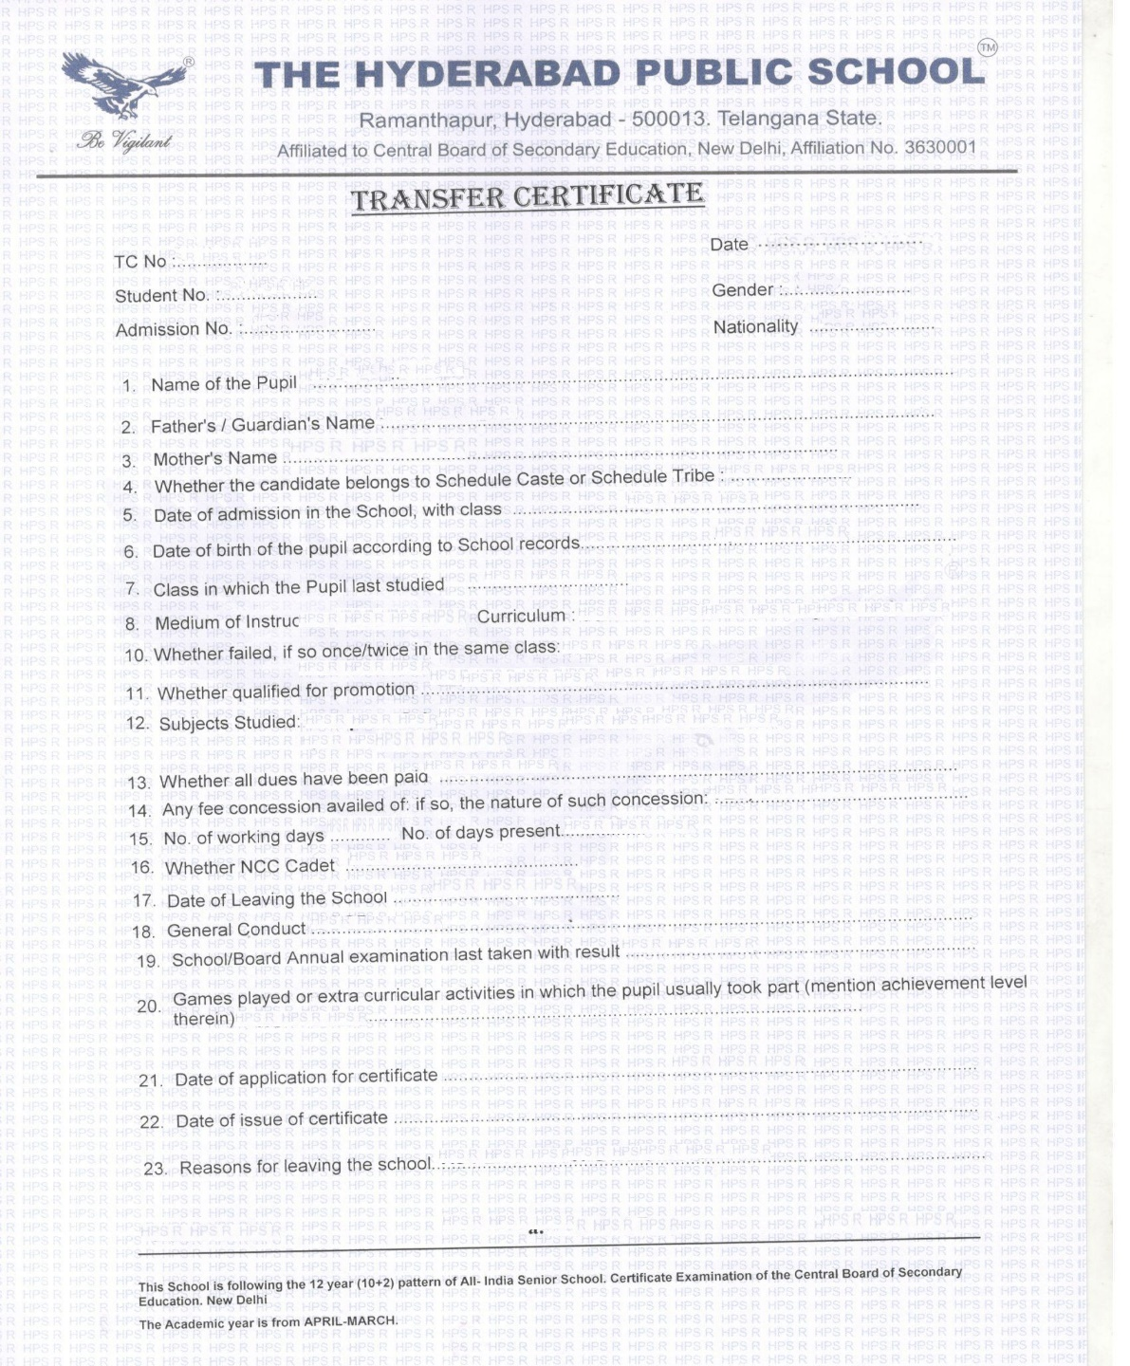
SAMPLE

5. Norms followed for fixing fee:
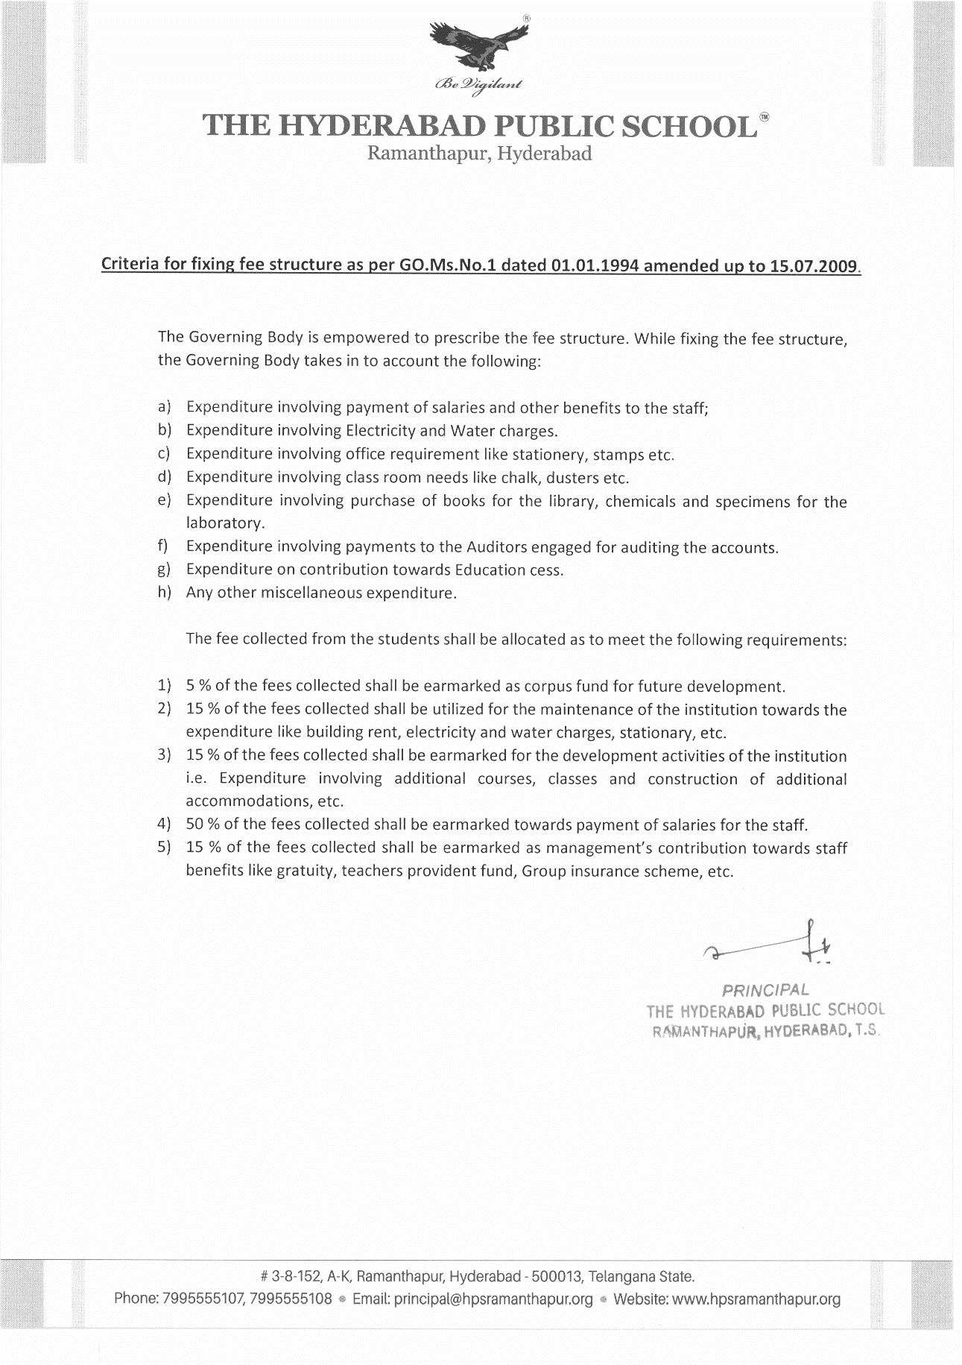

6. Self-Affidavit of the school:
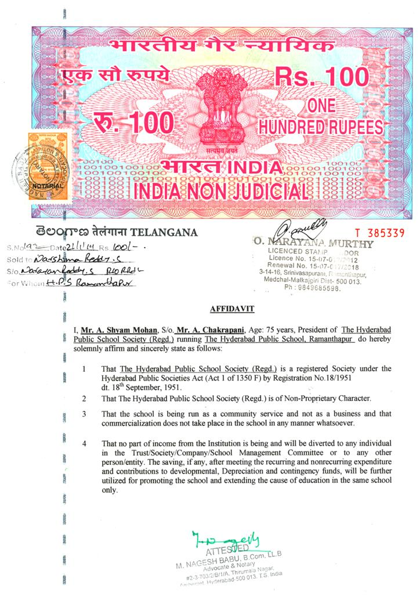
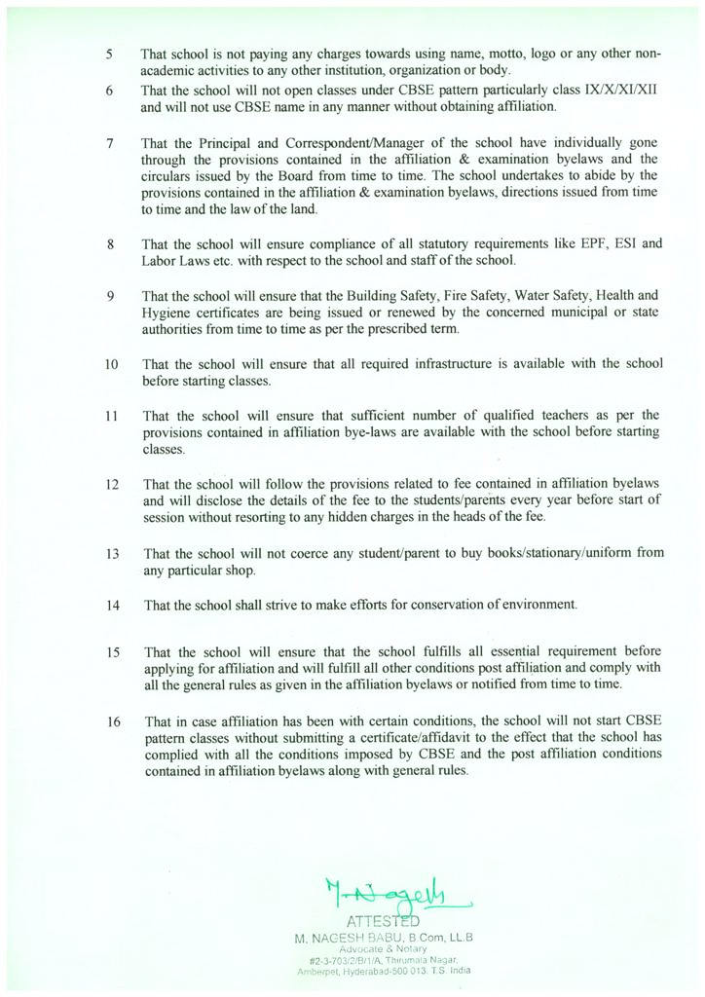
7. Affiliation Status (Middle /Secondary /Senior Secondary):
Middle / Secondary / Senior Secondary

8. Details of Infrastructure:
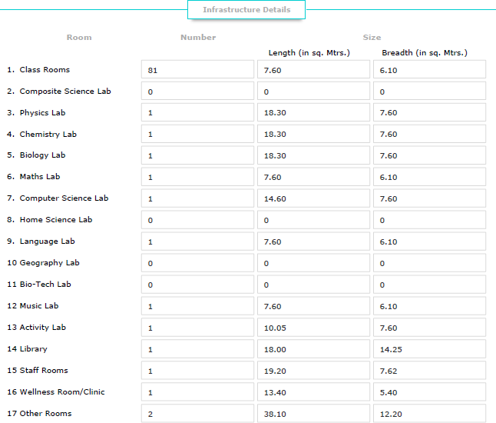

9. Details of teachers including qualification:
Sl.No. | Teacher Name | Type of Teacher | Academic Qualification | Professional Qualifications
1 | DR. S. NARASIMHA REDDY | PRINCIPAL | M.Sc. | B.Ed, Ph.D.
2 | KIRAN PANJWANI | VICE PRINCIPAL | B.Ed, M.A. (English) | PGCTE (EFLU)
3 | B NAGARJUN | PGT | B.Sc, | B.Ed, M.P.Ed.
4 | B. SWARNLATA | PGT | B.Com, M.Com, | B.Ed, Diploma in English.
5 | S. SRIKANTH | PGT | MCA | , M.Phil
6 | A. LAKSHMI TULASI | PGT | M.Sc., | B.Ed
7 | A. VENKATA LAKSHMI | PGT | M.Sc., | B.Ed.
8 | B. DEEPIKA | PGT | M.Sc., | M.Sc., B.Ed.
9 | T. S. SHEELA RANI | PGT | M.Sc., | M.Sc., B.Ed.
10 | G. DAYAMANI | PGT | M.Sc., | B.Ed.
11 | SWATI VERMA | PGT | English (Hons.), M.A. (English) | B.Ed.
12 | Y.SREEVALLI | PGT | M.Sc, Ph.D, B.Ed | B.Ed.
13 | K.SURESH | PGT | M.Sc., M.Phil., | , B.Ed.
14 | P.SATYA PRASAD | PGT | M.Sc. (Physics), | B.Ed.
15 | MADHAVI KOTARU | PGT | MA (ECO), B.Ed | B.Ed.
16 | R. PRAKASH RAO | TGT | Diploma in NTC, | NAC, TTC, CTI, ATI, Wood Work
17 | K. PRAMEELA | TGT | M.A, | M.A, B.Ed.
18 | MINNA SINGH | TGT | B.Sc., | B.Ed.
19 | D. V. RAMESH | TGT | B.Sc., | B.Sc., M.P.Ed., N.I.S.
20 | N.S. R. SHARMA | TGT |  | M.A., B.Ed.
21 | LALITHA PRAKASH | TGT | M.A, | M.A., B.Ed.
22 | D. MADHURI RANI | TGT | M.A, | M.A, TPT. M.Phil
23 | DIGAMBER SINGH D. | TGT | M.Sc., | M.Sc., B.Ed., PGDCA
24 | S. V. DEEPA | TGT | M.A, | M.A., B.Ed.
25 | G. PRAMOD REDDY | TGT | B.F.A, M.F.A | . (PAINTING)
26 | P. POORNAVALLI | TGT | B.Sc., | B.Ed.
27 | G. KAVITHA RAO | TGT | M.A, M.Phil., | M.A., M.P.Ed, (Phd)
28 | K. PADMA | TGT | M.Sc., | B.Ed.
29 | G. SREELATHA | TGT | M.Sc. | M. Tech (Computers)
30 | U. RAMA KRISHNA | TGT | M.A, M.Phil., | TPT
31 | S. APARNA | TGT | M.A. (History) | M.A., M. Com., B.Ed.
32 | J. APARNA | TGT | M.A. (History), | M.L.I.S.C.
33 | ANJU ARORA | TGT | M.Sc. (Chemsitry), | B.Ed.
34 | M SUMITHA REDDY | TGT | M.A., M.Phil. | B.Ed.
35 | C.BINDU | TGT | M.Sc., | B.Ed.
36 | K C GEETA | TGT | M.A., | B.Ed.
37 | MANEESHA SHARMA | TGT | M.Sc., (Zoology) | B.Ed.
38 | D. KRISHNA REDDY | TGT | M.A. | , TPT, Ph.D
39 | SRUTOKIRTI BANERJEE | TGT | M.A, | B.Ed.
40 | E PRISCILLA RANI | TGT | M.A., | B.Ed.
41 | AMITA RAO | TGT | B.A (Eng.Hons), M.A., M.Phil. | B.Ed (EFLU)
42 | BIJU THOMAS | TGT | M.Sc | B.Sc. B.Ed.
43 | PROMILA NATHANIEL | TGT | M.A. (English), | M.Ed.
44 | URMILA PANDEY | TGT | M.A (Hindi), | B.Ed.
45 | P USHA | TGT | M.Sc. (Maths) | B.Ed.
46 | INDULEKHA NAMBIAR | TGT | M.A (History) | B.Ed.
47 | K SANDHYA RANI | TGT | M.A (English) | B.Ed
48 | NISHA RACHEL KURUVILLA | TGT | B.Com, B.Ed, | PGDHRM
49 | BINDU G RAJEEVAN | PSYCHOLOGICAL COUNSELLOR | M.A,LLB | LLM, PGDCBM,CSWCJS, DYT, BAL
50 | J. MADHAVI | SPECIAL EDUCATOR | MCA, B.Ed | (Spl.Ed-LD)
51 | PRABHAT KUMAR | TGT | MA,MPHIL,B.Ed | HINDI
52 | STUTI V | CAREER COUNSELLOR
53 | T RAMA GEETHA | PST | MA TELUGU | TPT TELUGU,  PG Dip. In ECE
54 | D. PADMAVATI | HM | M.SC (PHYSICS) | B.ED, CIC
55 | N V RANGA RAJU | PST | BFA | B.Ed.
56 | K MERCY SIROMANI | PST | MA (ENGLISH) | B.ED
57 | KEERTHI MANGALVEDHE | PST | MA (HINDI) | B.ED, PPTTC
58 | KVSG PADMA | PST | BSc | BEd.
59 | V SRI RAMA | PST | BSc.M.A | B.Ed
60 | G GEETHA VANI | PST | M.PHIL  (TELUGU) | TPT TELUGU
61 | B. RAJITHA | PST | M.Sc (Chemistry) | B.Ed
62 | M SUNITHA | PST | M.SC(MATHS) | B.ED (MATHS & PHY.SCI)
63 | K SHANTI LATA | PST | B.SC. | B.ed.
64 | K. REVATHI | PST | M.PHIL (PURE MATHS) | B.ED
65 | C SRI DEVI | PST | M.PHIL | H.P.T
66 | N. GEETANJALI | PST | M.COM | PGDCA, SAP
67 | BHAVANI MUTNURI | PST | MA (ENGLISH) | B.ED, CIDTT
68 | K. SHAILAJA | PST | MA (ECONOMICS) | B.ED
69 | B.ARCHANA | PST | MA | B.ED
70 | NJSSK GOWRI | PST | MA (HINDI) | B.ED
71 | K.RAVI SUDHA | PST | MA (TELUGU) | B.ED
72 | SHEEKHA SACHDEVA | PST | B.SC | B.Ed
73 | K NILOHITA | PST | MA (PUBLIC ADM) | BEd.
74 | S ARUNASRI | PST | M.Sc (Comp) | BEd.
75 | L NAVEEN KUMAR | PST | MBA (Fin.& Mktg.) B.P.Ed. | B.P.Ed, NIS-Hockey,
76 | N. PREETHI HARISH KUMAR | PST | MDBA, DTE, CTET | B.Ed,
77 | DV NAGASAI | PST | MA DANCE | MA DANCE
78 | YASMIN KHAN | PST | B A | B.Ed
79 | Y VENKAT REDDY | PST | M.A., TPT | M.A., TPT
80 | K R RATNAM | PST | MA | B.Ed
81 | P ARUNA | PST | M A (ENGLISH) | B.Ed
82 | SHAZIA SULTANA | PST | M A (ENGLISH) | B.Ed
83 | RUTH SUNITHA | PST | MSc (BOTANY) | B.Ed
84 | JULIET DEVANANDINI | PST | MSC (PSYCHOLOGY) B. ED
85 | SAMPA SARMACHARJEE | PST | M.Sc., . | B.Ed
86 | M ANUSHA | PST | M.Sc. (MICROBIOLOGY) | B.Ed
87 | B NARASAMMA | PST | B.A., | B.F.A
88 | D SUPRIYA | PST | M.Sc | B.Ed.
89 | PAVANI GUDIMELLA | PST | M.Sc | B.Ed.
90 | SADIA TABASSUM | PST | MA | B.Ed
91 | B.SUDHA SHALINI | Pre-primary Teacher, I/c | M.A, | B.Ed
92 | LAKSHMI LAL | Pre-primary Teacher | M.A, | P.G diploma in ECE
93 | SAMAYITA BHATTACHARYA | Pre-primary Teacher | B.Com, | PPTC,ECCED
94 | JYOTHIRMAI SAMPADARAO | Pre-primary Teacher | M.Sc, | PPTTC
95 | PADMA SINGH | Pre-primary Teacher | Masters in IT, | P.G diploma in ECE
96 | K.ANURADHA | Pre-primary Teacher | B.Com, | B.Ed(pursuing), P.G diploma in ECE
97 | MADHURI PISSAPATI | Pre-primary Teacher | MCA, | P.G diploma in ECE, CICTT
98 | RAJANI PRIYA | Pre-primary Teacher | B.Com. | B.Ed. , ECCE

10. The number of students class wise:
TOTAL STRENGTH FROM CLASS PP1-12 FOR 2020-21
Class | As on 19-11-20 | Class total
PPI - A | 25 | 123
PPI - B | 24
PPI - C | 24
PPI - D | 25
PPI - E | 25
PPII - A | 26 | 124
PPII - B | 23
PPII - C | 25
PPII - D | 25
PPII - E | 25
1 - A | 36 | 168
1 - B | 32
1 - C | 33
1 - D | 34
1 - E | 33
2 - A | 36 | 179
2 - B | 34
2 - C | 37
2 - D | 37
2 - E | 35
3 - A | 42 | 199
3 - B | 42
3 - C | 39
3 - D | 39
3 - E | 37
4 - A | 41 | 209
4 - B | 41
4 - C | 42
4 - D | 43
4 - E | 42
5 - A | 42 | 213
5 - B | 40
5 - C | 44
5 - D | 43
5 - E | 44
6 – A | 42 | 209
6 – B | 41
6 – C | 42
6 – D | 43
6 - E | 41
7 – A | 39 | 208
7 – B | 42
7 – C | 43
7 – D | 42
7 - E | 42
8 – A | 43 | 207
8 – B | 42
8 – C | 42
8 – D | 40
8 – E | 40
9 – A | 40 | 160
9 – B | 40
9 – C | 40
9 – D | 40
10 – A | 43 | 163
10 – B | 38
10 – C | 42
10 – D | 40
11 – A | 40 | 71
11 – B | 31
12 - A | 33 | 62
12 - B | 29
TOTAL | 2295 | 2295

11. Postal address and e-mail, telephone no’s of school and authorities:
The Hyderabad Public School,
#3-8-152, A-K, Ramanthapur,
Hyderabad,Telangana State,
Pin Code: 500013.
Contact Numbers:
PA to Principal : +91 7995555108
PA to Vice Principal: +91 7995555107
Admissions Office : +91 7995555104
Accounts Office : +91 7995555105
JPW : +91 7995555101
UPW : +91 7995555102
Email Id : contactus@hpsramanthapur.org

12. List of books prescribed in various classes:
Private Publishers for Academic Year 2018-19
SUBJECT | TITLE OF THE BOOK | PUBLISHER
PP-1 BOOKS LIST FOR THE YEAR 2020-21
English | Pre-School Big Small letters | Grafalco
English | Pre-School English Activity book | Grafalco
English | Pre-School Phonic (3) Picture book | Grafalco
English | Picture Dictionary | Sadhana Publication
Number work | Pre-School Numbers (0-9) | Grafalco
Craft | Pre-School Drawing (C) | Grafalco
Craft | Pre-School Drawing (B) | Grafalco
PP-2 BOOKS LIST FOR THE YEAR 2020-21
SUB | TITLE | PUB
English | Pre-School Print Capital and Small letters | Grafalco
English | Pre-School Phonic Prime Reader | Grafalco
English | Picture Dictionary | Sadhana Publication
Number work | Pre-School Numbers (1-100) | Grafalco
Hindi | Bade Akshar Swar | Grafalco
Hindi | Bade Akshar Venjan | Grafalco
Telugu | Telugu Sachitra Varnamala | Vysa Publications
Craft | KG Drawing 1 | Navneet Education Limited
Craft | KG Drawing 2 | Navneet Education Limited
 | CLASS I
Subject | Title of the Book  (2020-21) | Name of the Publisher  (2020-21)
English, Maths, EVS & GK | Breeze - 1  An Integrated Semester 1 & Semester 2 | Collins Publishers
 | Lines and Curves - Cursive Writing - 1 | Evergreen Publications
English | Picture Dictionary | Collins Publishers
Telugu (L2) | Jabili - 1 | Govt. of Telangana
 | Sadhana Telugu copy - 1 | Sadhana Publications
Hindi (L2) | Surya Kiran - I | Mac Millan
 | Hindi Sulekhan - I | Grafalco Publishers
Telugu (L3) | Tenepalukulu - 1(Special Telugu) | Govt. of Telangana
 | Telugu Sachitra Varnamala -1 | Sadhana Publications
Art | Candid Go Creative -1 | Evergreen Publications (India) Ltd
 | CLASS II
Subject | Title of the Book  (2020-21) | Name of the Publisher  (2020-21)
English, Maths, EVS & GK | Breeze - 2  An Integrated Semester 1 & Semester 2 | Collins Publishers
 | Lines & Curves - Cursive Writing 2 | Evergreen Publications (India) Ltd
English | Picture Dictionary | Collins Publishers
Telugu (L2) | Jabili - 2 | Govt. of Telangana
 | Sadhana Telugu copy - 2 | Sadhana Publications
Hindi (L2) | Surya Kiran - 2 | Mac Millan
 | Hindi Sulekhan - 2 | Grafalco Publishers
Telugu (L3) | Tenepalukulu - 2(Special Telugu) | Govt. of Telangana
 | Telugu Sachitra Varnamala -2 | Sadhana Publications
Art | Candid Go Creative - 2 | Evergreen Publications (India) Ltd
 | CLASS III
Subject | Title of the Book  (2020-21) | Name of the Publisher  (2020-21)
English | Revised New pathways MCB-3 | Oxford Publishers
 | Revised New pathways L.R-3 | Oxford Publishers
 | Oxford Pocket Dictionary | Oxford Publishers
Telugu (L2) | Jabili - 3 | Govt. of Telangana
 | Sadhana Telugu copy - 3 | Sadhana Publications
Hindi Text book (L2) | Surya Kiran - 3 | Mac Millan
 | Hindi Sulekhan - 3 | Grafalco Publishers
Telugu (L3) | Tenepalukulu - 3(Special Telugu) | Govt. of Telangana
 | Telugu Sachitra Varnamala -3 | Sadhana Publications
Mathematics | New Enjoying Mathematics - 3  By Ashalata Badami | Oxford Publishers
General Science | Candid new trends in Science | Evergreen Publications (India) Ltd
Social Studies | New Getting ahead in Social Studies  By Abha Sahgal , Sushmita Malik | Orient Black Swan
Computer Science | Keyboard- Windows 10 & MSOffice 2016 - 3 | Oxford Publishers
General Knowledge | Active General Knowledge-3 | Sharada Press Full circle Education Pvt ltd
Art/Craft | Candid Go Creative-3 | Evergreen Publications (India) Ltd
 | CLASS IV
Subject | Title of the Book  (2020-21) | Name of the Publisher  (2020-21)
English | Revised New pathways MCB-4 | Oxford Publishers
 | Revised New pathways L.R-4 | Oxford Publishers
Telugu (L2) | Jabili - 4 | Govt. of Telangana
 | Sadhana Telugu copy - 4 | Sadhana Publications
Hindi Text book(L2) | Surya Kiran - 4 | Mac Millan
 | Hindi Sulekhan - 4 | Grafalco Publishers
Mathematics | New Enjoying Mathematics - 4  By Ashalata Badami | Oxford Publishers
General Science | Candid new trends in Science -4 | Evergreen Publications (India) Ltd
Social Studies | New Getting ahead in Social Studies  By Abha Sahgal , Sushmita Malik | Orient Black Swan
 | Oxford School Atlas | Oxford Publishers
Computer Science | Keyboard- Windows 10 & MSOffice 2016 - 4 | Oxford Publishers
General Knowledge | Active General Knowledge-4 | Sharada Press Full circle Education Pvt ltd
Art/Craft | Candid Go Creative-4 | Evergreen Publications (India) Ltd
 | CLASS V
Subject | Title of the Book  (2020-21) | Name of the Publisher  (2020-21)
English | Revised New pathways MCB-5 | Oxford Publishers
 | Revised New pathways L.R-5 | Oxford Publishers
Telugu (L2) | Jabili - 5 | Govt. of Telangana
 | Sadhana Telugu copy - 5 | Sadhana Publications
Telugu (L3) | Jabili - 1 | Govt. of Telangana
 | Telugu Sachitra Varnamala | Sadhana Publications
 | Telugu Gunintalu | Sadhana Publications
Hindi (L2) | Surya Kiran - 5 | Mac Millan
 | Hindi Sulekh -5 | Grafalco
Hindi (L3) | Surya Kiran - 1 | Mac Millan
 | Hindi Sulekh -1 | Grafalco
L3 ( SANSKRIT) | SANSKRITH MANJUSHA | SARASWATI HOUSE PVT LTD
Mathematics | New Enjoying Mathematics - 5  By Ashalata Badami | Oxford Publishers
General Science | Candid new trends in Science - 5 | Evergreen Publications (India) Ltd
Social Studies | New Getting ahead in Social Studies  By Abha Sahgal , Sushmita Malik | Orient Black Swan
Computer Science | Keyboard- Windows 10 & MSOffice 2016 - 5 | Oxford Publishers
Art/Craft | Candid Go Creative-5 | Evergreen Publications Ltd
ENGLISH | OXFORD REVISED NEW PATHWAYS-LITERATURE READER -6(Third edition-2020) | Oxford University Press
ENGLISH | OXFORD REVISED NEW PATHWAYS-COURSE BOOK -6(Third edition-2020) | Oxford University Press
ENGLISH | OXFORD ENGLISH DICTIONARY FOR SCHOOLS | Oxford University Press
SOCIAL STUDIES | STUDENT SCHOOL ATLAS | OXFORD
L2 ( TELUGU) | NAVAVASANTAM 1 | TS GOVT
COMPUTER SCIENCE | HYPERLINK-6 | KIPS
ENGLISH | OXFORD REVISED NEW PATHWAYS-LITERATURE READER -7(Third edition-2020) | Oxford University Press
ENGLISH | OXFORD REVISED NEW PATHWAYS-COURSE BOOK -7(Third edition-2020) | Oxford University Press
L2 ( TELUGU) | NAVAVASANTAM 2 | TS GOVT
L3 TELUGU | VENNELA 2(TELUGU VACHAKAM) | TS GOVT
L3 ( SANSKRIT) | SANSKRIT MANJUSHA-2 | SARASWATI HOUSE PVT LTD
L3 HINDI | MADHURIMA-3 | FRANK EDUCATIONAL HOUSE PVT LTD
L2 ( HINDI) | NAYEE SWATHI-7 | NEW SARASWATHI HOUSE PVT LTD
L2 HINDI | NANDINI-7 | INSPRITION PUBLICATION
COMPUTER SCIENCE | HYPERLINK-7 | KIPS
ENGLISH | OXFORD REVISED NEW PATHWAYS-LITERATURE READER -8(Third edition-2020) | Oxford University Press
ENGLISH | OXFORD REVISED NEW PATHWAYS-COURSE BOOK -8(Third edition-2020) | Oxford University Press
L2 ( TELUGU) | NAVAVASANTAM 3 | TS GOVT
L3 TELUGU | JABILI 4 | TS GOVT
L3 SANSKRIT | SANSKRIT MANJUSHA-3 | SARASWATI HOUSE PVT LTD
L3 HINDI | MADHURIMA-4 | FRANK EDUCATIONAL HOUSE PVT LTD
L2 ( HINDI) | NAYEE SWATHI-8 | NEW SARASWATHI HOUSE PVT LTD
L2 HINDI | NANDINI-8 | INSPRITION PUBLICATION
COMPUTER SCIENCE | HYPERLINK-8 | KIPS
Science | CORE SCIENCE LAB MANUAL-9 | Goyal Brothers Prakashan
MATHS | Mathematics for class IX - RD Sharma | DHANPAT RAI PUBLICATIONS
SOCIAL | RELIABLE QUESTION BANK | RELIABLE ENTER PRISES
SOCIAL STUDIES | DISASTER MANAGEMENT | GOYAL BROTHERS
L2 TELUGU | SINGIDI-1 | TS GOVT
TELUGU | JATHIYA SAMPADA | SHIVA RAMAKRISHNAIAH
HINDI | VYAAKARAN PRAVESH | FULL MARK PVT LTD
COMPUTER SCIENCE | COMPUTER APPLICATIONS BY KIPS LEARNING SOLUATION | KIPS
Science | CORE SCIENCE LAB MANUAL-10 | Goyal Brothers Prakashan
MATHS | Mathematics for class X - RD Sharma | DHANPAT RAI PUBLICATIONS
SOCIAL | RELIABLE QUESTION BANK | RELIABLE ENTER PRISES
SOCIAL STUDIES | DISASTER MANAGEMENT | GOYAL BROTHERS
TELUGU-L2 | SINGIDI-2 | TS GOVT
COMPUTER SCIENCE | COMPUTER APPLICATIONS BY KIPS | KIPS
physics | Physics Laboratory manual (goyal) | Goyal Brothers Prakashan
chemistry | PRACTICAL LAB CHEMISTRY (lakshmi pub) | Lakshmi Publications
Biology | Practical Manual for Class XI | Lakshmi Publications
MATHS | M L AGGARWAL (two volumes) | Arya Publishing Co.
COMPUTER SCIENCE | COMPUTER SCIENCE WITH PYTHON | SUMITHA ARORA
Accountancy | Double Entry Book Keeping | Sultan Chand
BUSINESS STUDIES | BUSINESS STUDIES | VK GLOBAL PUB PVT LTD BY DR. R K SINGLA
PHYSICAL EDUCATION | CBSE A TEXT BOOK OF PHYSICAL EDUCATION | EVERGREEN PUBLICATIONS
 | PHYSICAL EDUCATION RECORD- CLASS11 | EVERGREEN PUBLICATIONS
ECONOMICS | STATISTICS FOR ECONOMICS | DHANPAT RAI & CO BY RADHA BHYGUNA
 | INTRODUCTORY MICRO ECONOMICS | DHANPAT RAI & CO BY RADHA BHYGUNA
physics | Physics Laboratory manual (goyal) | Goyal Brothers Prakashan
chemistry | PRACTICAL CHEMISTRY (lakshmi pub) | Lakshmi Publications
Biology | Practical Manual for Class XII | Lakshmi Publications
ENGLISH | Together with -English Core Practice Material | Rachna Sagar
MATHS | M L AGGARWAL (two volumes) | Arya Publishing Co.
COMPUTER SCIENCE | COMPUTER SCIENCE WITH PYTHON | SUMITHA ARORA
Accountancy | Double Entry Book Keeping- VOLUME-1 | Sultan Chand
Accountancy | Double Entry Book Keeping- VOLUME-2 | Sultan Chand
Accountancy | Analysis of Financial Statement - PART-2 | Sultan Chand
ECONOMICS | INDIAN ECONAMICS DEVELOPMENT | DHANPAT RAI & CO BY RADHA BHYGUNA
 | INTRODUCTORY MACRO ECONOMICS | DHANPAT RAI & CO BY RADHA BHYGUNA
BUSINESS STUDIES | BUSINESS STUDIES | R K SINGLA , VK GLOBAL
PHYSICAL EDUCATION | CBSE A TEXT BOOK OF PHYSICAL EDUCATION | EVERGREEN PUBLICATIONS
 | PHYSICAL EDUCATION RECORD- CLASS12 | EVERGREEN PUBLICATIONS
PHYSICS | Navneet's Logarithamic and Mathematical tables | NAVNEET PUB

NCERT /CBSE PUBLISHERS -2020 - 21
SUBJECT | CLASS | TITLE OF THE BOOK | PUBLISHER
ENGLISH | class9 | ENGLISH MAIN COURSE BOOK NCERT | CBSE
 |  | ENGLISH LITERATURE READER | CBSE
 |  | ENGLISH WORK BOOK | CBSE
 |  | BEEHIVE- LITERATURE | NCERT
 |  | MOMENTS- SUPREADER | NCERT
 | CLASS-10 | ENGLISH MAIN COURSE BOOK NCERT | CBSE
 |  | ENGLISH LITERATURE READER | CBSE
 |  | ENGLISH WORK BOOK | CBSE
 | CLASS-11 | HORN BILL ENGLISH -NCERT | NCERT
 |  | SNAP SHOTS ENGLISH- NCERT | NCERT
 | CLASS-12 | FLAMINGO ENGLISH (T.B)- NCERT | NCERT
 |  | VISTAS ENGLISH SUPPLIMENTARY- NCERT | NCERT
SCIENCE | CLASS 6 | SCIENCE TEXT BOOK , NCERT | NCERT
 | CLASS 7 | SCIENCE TEXT BOOK , NCERT | NCERT
 | CLASS 8 | SCIENCE TEXT BOOK , NCERT | NCERT
 | CLASS 9 | SCIENCE TEXT BOOK , NCERT | NCERT
 | CLASS 10 | SCIENCE TEXT BOOK , NCERT | NCERT
 | CLASSS 11 | PHYSICS TEXT-BOOK VOL 1-NCERT | NCERT
 |  | PHYSICS TEXT-BOOK VOL 2- NCERT | NCERT
 | CLASSS 12 | PHYSICS TEXT-BOOK VOL 1- NCERT | NCERT
 |  | PHYSICS TEXT-BOOK VOL 2- NCERT | NCERT
 | CLASS 11 | CHEMISTRY TEXT-BOOK VOL 1 | NCERT
 |  | CHEMISTRY TEXT-BOOK VOL 2 | NCERT
 | CLASS 12 | CHEMISTRY TEXT-BOOK VOL 1 | NCERT
 |  | CHEMISTRY TEXT-BOOK VOL 2 | NCERT
 | CLASS 11 | BIOLOGY-TEXT BOOK | NCERT
 | CLASS 12 | BIOLOGY-TEXT BOOK | NCERT
HINDI | CLASS 9 | SPARSH-1 (L-2 HINDI) | NCERT
 | CLASS 9 | SANCHAYAN-1 (L-2 NON DETAIL) | NCERT
 | CLASS 10 | SPARSH-2 (L-2 HINDI) NCERT | NCERT
 | CLASS 10 | SANCHAYAN-2 (NON DETAIL) | NCERT
MATHS | CLASS 3 | Math-Magic 3 | NCERT
 | CLASS 4 | Math-Magic 4 | NCERT
 | CLASS 5 | Math-Magic 5 | NCERT
 | CLASS 6 | TEXT-BOOK FOR MATHS-6 (NCERT) | NCERT
 | CLASS 7 | TEXT-BOOK FOR MATHS-7 (NCERT) | NCERT
 | CLASS 8 | TEXT-BOOK FOR MATHS-8 (NCERT) | NCERT
 | CLASS 9 | TEXT-BOOK FOR MATHS-9 (NCERT) | NCERT
 | CLASS 10 | TEXT-BOOK FOR MATHS-10 (NECRT) | NCERT
 | CLASS 11 | A TEXT BOOK FOR MATHS-11 - NCERT | NCERT
 | CLASS 12 | MATHS( J V NARLIKARCHAIR) PART-I | NCERT
 | CLASS 12 | MATHS( J V NARLIKARCHAIR) PART-2 | NCERT
BS | CLASS 12 | PART 1 : BUSINESS STUDIES ( PRINCIPLES AND FUNCTIONS OF MANAGEMENT) | NCERT
 | CLASS 12 | PART 2 : BUSINESS STUDIES AND MARKETTING) | NCERT
SOCIAL | CLASS 6 | OUR PASTS 1(HISTORY) | NCERT
 |  | THE EARTH OUR HABITAT(GEO) | NCERT
 |  | SOCIAL AND POLITICAL LIFE I | NCERT
 | CLASS7 | OUR PASTS II(HISTORY) | NCERT
 |  | OUR ENVIRONMENT(GEO) | NCERT
 |  | SOCIAL AND POLITICAL LIFE II | NCERT
 | CLASS 8 | OUR PASTS II(HISTORY) PART 1 | NCERT
 |  | OUR PASTS II(HISTORY) PART 2 | NCERT
 |  | RESOURCES AND DEVELOPMENT(GEO) | NCERT
 |  | SOCIAL AND POLITICAL LIFE III | NCERT
 | CLASS 9 | HISTORY-India and Contemporary world-1 -NCERT | NCERT
 | CLASS 9 | CIVICS -Democractic Politics -1- NCERT | NCERT
 | CLASS 9 | GEOGRAPHY-Contemporary India- I -NCERT | NCERT
 | CLASS 9 | ECONOMICS-Text Book-IX- NCERT | NCERT
 | CLASS 10 | Social HISTORY-India & Contemporary World-II- NCERT | NCERT
 | CLASS 10 | SOCIAL CIVICS -Democractic Politics -II- NCERT | NCERT
 | CLASS 10 | GEOGRAPHY-Contemporary India-II - NCERT | NCERT
 | CLASS 10 | ECONOMICS-Text Book-X- NCERT | NCERT

13. 2019 - 20 Annual Report & Academic achievements along with, write up on all efforts made in the field of environment education, sports.

ANNUAL REPORT OF HPS RAMANTHAPUR– 2019-20
- ACADEMICS:
THE YEAR 2019—2020 STUDENTS PASSED OUT WITH FLYING COLOURS. IT WAS 100% RESULT IN BOTH CLASS X AND CLASS XII. AKHILA DANTU STOOD AS TOPPER IN CLASS 10 SECURING 97.2% AND BISHWANTH BAJI AS SCHOOL TOPPER IN SCIENCE STREAM SECURING 95% .
SCHOOL EVENTS
- INVESTITURE CEREMONY:
The investiture ceremony for the year 2019-20 was a grand celebration of new responsibilities and much desired capabilities. The chief guest for the day was Air Commodore, N. Narender Reddy who, through his speech shared the principles of success and the importance of discipline.

GRADUATIONDAY
The annual Graduation Ceremony is a day devoted to celebrate in every student’s life which was held on 21st June, 2019 for the 2018-19 batch. It was a great honor to have amidst us Dr.R.Hemalatha who graced the occasion as the chief guest. She is the Director of NIN (National Institute of Nutrition) who is heading clinical division and microbiology and immunology.

- SCHOOL EXHIBITION
The Annual School Exhibition was held on 8th of August 2019. The school conducts this exhibition every year because it realizes that new ideas grow in the minds of the young children and these are the platforms where ideas begin to bloom for the development of the world at large.

Around 850 students took part and 446 exhibits were on display. The Chief Guest for the occasion was Dr.D.Srinagesh, Chief Scientist, Head Seismology Observatory, NGRI . He was accorded a warm welcome by the school Principal Dr.Narasimha Reddy.

- KARGIL VIJAY DIWAS
On the 22ND of July, 2019 our navy cadets took part in a painting competition on the occasion of Kargil Vijay Diwas. 50 cadets of Naval Unit took part in the activity.
- NAVY DAY
On Dec 3rd, our school celebrated the Navy Day. On this occasion, all the boards in the school were decorated with charts showcasing the history and vitality of Indian navy and NCC.
- International Yoga Day
It was a pleasant morning on the 21st June, 2019 where 50 senior navy cadets and around 50 school boarders assembled in the school auditorium for the celebration of International Yoga

- NATIONAL YOUTH DAY- Our Visit to Ramakrishna Math
- A group of 40 students from our school visited Ramakrishna Math, DomalGuda, on 12th January , 2020 on the occasion of the birthday of Swami Vivekananda
- PRINCIPALS SUMMIT HELD ON 26TH JUNE 2019. 67DELEGATES FROM REPUTED SCHOOLS ATTENDED DR. RAVINDRAN DIRECTOR GENERAL OF ICTRTC WAS THE RESOURCE PERSON.

- THE HYDERABAD PUBLIC SCHOOL RAMANTHAPUR CONDUCTED ORIENTATION PROGRAMME FOR PRINCIPALS IN THE “HUBS OF LEARNING” AROUND 200 PRINCIPALS FROM BOTH STATES OF TELANGANA AND ANDHRA PRADESH ATTENDED THE CONFERENCE.M.V.V. PRASADA RAO FROM THE CENTRE OF EXCELLENCE WAS THE RESOURCE PERSON.

- SAHODAYA CLUSTERS PRINCIPAL MEET WAS HELD ON 5TH DECEMBER 1029 AT SAINIKPURI.
ONLINE ORIENTATION PROGRAMME ON ALTERNATIVE ACADEMIC CALENDAR CONDUCTED BY MANOJ AHUJA-IAS CHAIRMAN CBSE, DR. HRUSHIKESH SENAPATHY-DIRECTOR OF NCERT STUDENTS ACTIVELY PARTICIPATED IN MERIDIAN SCHOOL AND WON VARIOUS PRIZES IN VARIOUS CATEGORIES COMPETITION LIKE FASHIONISTA, RANGASTHALAM ETC.
- DRS INTERNATIONAL KOMPALLY- CONDUCTED MODEL UNITED NATION COMPETITION .11 STUDENTS FROM HPS PARTICIPATED IN DRSMUN AND WON 8 PRIZES IN VARIOUS CATEGORIES.

- HPSMUN WAS CONDUCTED ON 7TH AND 8TH NOVEMBER 2019. STUDENTS OF AGE GROUP 13 TO 18 ACTIVELY PARTICIPATED IN THE EVENT.
- OUR SCHOOL BEING A MEMBER OF AFS (AMERICAN FIELD SERVICE STUDENTS PARTICIPATED IN VARIOUS PROGRAMMES CONDUCTED BY AFS.AS A PART OF DOMESTIC CULTURE EXCHANGE 20 STUDENTS HAVE VISITED SALAQUI SCHOOL LOCATED IN DEHRADUN IN THE MONTH OF NOVEMBER.JAHNVI OF CLASSXII ENTHUSIASTICALLY PARTICIPATED AND WON FIRST PRIZE IN SLAM POETRY CONTEST.
- K. ANEESH OF CLASS 10 HAS BEEN SELECTED FOR ASIA KAKEHASHI PROGRAMME WHO WILL STUDY HIS CLASS 11 AT JAPAN FUNDED BY JAPANESE GOVT. THIS EVENT IS POSTPONED DUE TO COVID-19
- DPS NACHARAM LINGUA FIESTA- INTERSCHOOL TELUGU EXTEMPORE: AKAKSHA OF 10 B BAGGED 3RD PRIZE.
- SATRANJ ART FESTIVAL AT GLENDALE ACADEMY:THE PROGRAMME WAS HELD ON 5TH AUGUST 2019. MANAS OF 10C BAGGED FIRST PRIZE IN PHOTOGRAPHY.
- POSTER MAKING COMPETITION AT REQUELFORD INTERNATIONAL SCHOOL:ARJUN REDDY OF 8 A GOT FIRST PRIZE IN POSTERMAKING
- GLENDALE ACADEMY:ARJUN REDDY OF 8A WON SECOND PRIZE IN PAINTING COMPETITION ON 1ST AUGUST 2019
- GEO MAP QUIZ: MANY STUDENTS ACTIVELY PARTICIPATED IN CARTOGRAPHY QUIZAT DURGAM CHERUVU JUBILEE HILLS ON 7. 12. 2019 AND OUR STUDENTS BAGGED 4TH AND 6TH POSITION IN SUB JUNIORS.
- HPS BEGUMPET: R. SOHANAND AND PREM SIDDHARTH OF 9C GOT EXCELLENCE AWARD IN QUIZ COMPETITION HELD AT HPS BEGUMPETAS A PART OF IPSE-IT FEST.
- QUIZ COMPETITION HELD AT CCMB: ABHISHEK BIRADAR AND K. ANEESH OF 10C PARTICIPATED IN THE WILD QUIZ COMPETITION AND WON CONSOLATION PRIZE.
- ARJUN REDDY OF 8A PARTICIPATED IN THE DRAWING COMPETITION HELD AT CCMB LABORATORYFOR THE COSERVATION OF ENDANGERED SPECIESON 5TH OCT 2019AND WON FIRST PRIZE.
- VIKRAM SARABHAI CENTENARY PROGRAMME CONDUCTED BY ISRO TO COMMEMORATE THE BIRTH CENTENARY OF VIKRAM SARABHAI ON THE 14TH AND 15TH OF OCTOBER2019 BALANAGAR.OUR SCHOOL CHILDREN WON PRIZES IN VARIOUS COMPETITIONS PICK AND SPEAK,PAINTING COMPETITION AND QUIZ COMPETITION.
- VIGILANCE AWARENESS WEEK: CONDUCTED BY ANDHRA BANK: CHILDREN BAGGED PRIZES IN ELOCUTION AND ESSAY WRITING COMPETITION.

- Refugee Day
Save the Children organised the celebrations of World Refugee Day on 18th July 2019. The students of Grade 11 and 12 of the Hyderabad Public School, Ramanthapur were indeed honoured to be a part of such an event.
The dignitaries for the day were Chief Guest Mr.Suresh – Honorary counsel of Korea, Mr.Tarun Joshi – IPS Joint Commissioner of Hyderabad, Mr.Yukiko Koyama – Sr.Protection Officer (UNHCR), Sachidananda Michael Valan – South India Representative (UNHCR) , Mr.Vikas Gora – State Programme Manager, Save the Children and Mrs. Prasanthi Bathina – Asst. State Programme Manager, Save the Children who had all taken the lead to organise this glorious event.
- Green your school contest 2019
Aneesh along with M. Rakshith and P. Karthik participated in this prestigious and unique contest. Students presented PowerPoint presentation on the green measures taken by our school and gave their ideas to make the school environment more sustainable. The solar power plant established in our school was the most significant one. Our school was honored with IGBC Platinum rating award, the topmost rating given to any school.
On 28th of September a group of 10 students were accompanied by 2 teachers to participate in the inspiring series for school children as a part of Green your school Mrs. Uma Sudhir, Chief Editor, NDTV and famous vocalist Mrs. Manasi Prasad, were the speakers of this session.
- HEALTH CAMP
A free dental checkup camp was organized for the third time in the school campus from 13th to 19th August, 2019 by Dr.Sampath Reddy, Pediatric Dentist and an alumnus of HPSR from the Smile Foundation. There was a Mobile Dental Hospital to facilitate the checkup. Around 1,921 students from classes 1-12 availed the opportunity to get their teeth checked .
A free eye checkup camp was also organized from 13th to 19th August, 2019 for the classes 1-12.
- TEACHERS HEALTH CAMP
The teachers’ health camp was conducted by the Vijaya Diagnostic Centre on 15th September, 2019 between 8am to 4pm. The teaching staff and the non-teaching staff availed the opportunity. The tests such as Body Fat Percentage, Muscle Mass, Bone Mass, Body Mass Index (BMI) etc. were conducted.

- Fire Drill
A fire safety demonstration drill was conducted in the school football field on 12th July 2019 by a group of police officials and fire brigade. Various preventive measures that one must follow during a fire breakout scenario were also discussed in detail with students of grades 8-12.

- SAHODAYA MEET
ON 24TH JUNE OUR PRINCIPAL DR. NARASIMHA REDDY WAS ELECTED AS THE CHAIRMANOF THE THE HYDERABAD SHAODAYA SCHOOLS COMPLEX FOR THE ENTIRE CITY OF HYDERABAD. IT COVERS ALL THE CBSE SCHOOLS OF HYDERABAD.
- SNU
It was a three day visit from 2nd – 4th October 2019 , where students witnessed the performances of SNU’s musical band, ‘SNUphoria’ and the dance team ,’Inferno’ on the first day. Second day i.e on 3rd October a motivational speech delivered by Ms. Rupamanjari Ghosh, Vice chancellor of the SNU. Students were introduced to the other clubs, TEDx talks and business cum startup ideologies by the young budding minds of SNU .

- INFRASTUCTURE:
AQUARIUM WAS SETUP IN PRE-PRIMARY WING,
SAFETY GRILLS WERE PUT EVERYWHERE.
FIRE EXTINGUISHER WERE PUT AT NECESSARY PLACES
A ROOM WAS ALLOTED NEAR PARKING LOT FOR NCC WING

- ACCOLADES AND AWARDS
GLOBAL INNOVATIVE SCHOOL AWARD 2019 FOR THE BEST PEDAGOGICAL PRACTICES IN TEACHING AND LEARNING PROCESS.
TIMES EDUCATION EXCELLENCE AWARD FOR ACADEMIC EXCELLENCE FROM TIMES GROUP.
AWARD OF INCLUSIVENESS FROM ELDROK PRVT LTD
TWO STUDENTS WON A CASH AWARDS OF Rs. 5ooo and Rs. 1000 for EXCELLING IN IEO.
THE HYDERABAD PUBLIC SCHOOL RAMANTHAPUR WON PLANTINUM AWARD IN GREEN YOUR SCHOOL CONTEST WHERE OUR PRINCIPAL DR. NARASIMHA REDDY WAS HONOURED BY IGBC ON 27TH OF SEPTEMBER AT NOVETEL HYDERABAD.

SPORTS AND GAMES
IPSC VOLLEYBALL TOURNAMENT2019 WAS HELD IN THE HYDERABAD PUBLIC SCHOOL RAMANTHAPUR ON 28TH SEPTEMBER 2019. AROUND 130 PARTICIPANTS FROM 9 SCHOOLS FROM DIFFERENT PARTS OF THE COUNTRY ATTENDED THIS TOURNAMENT.
Athletics :
- Our students took part in the Hyd Dist SGF Inter School Athletics tournament organized by Hyderabad Dist School Games Federation from 01/08/2019 to 03/09/2019 held at GCPE grounds Gaganmahall and won 6 gold, 3 silver,3 bronze medals
- Our students took part in the CBSE Cluster Inter School Athletics organized by CMR International school, Suraram, Hyderabad from 27/09/2019 to 30/09/2019 and won one gold one silver and one bronze and won 6 gold, 3 silver,3 bronze medals. The following students are further selected to take part in the CBSE Cluster National Athletic Meet 2019 to be held at Allions Public School, Raipur from 26th to 29th Sept’2019.
Volley ball:
- Our u/17 yrs volley ball team took part in the Hyd Dist SGF Inter School Athletics tournament organized by Hyderabad Dist School Games Federation from 01/08/2019 to 03/09/2019 held at LB Stadium and won fourth position Master Pradeep David Raju of class X is selected to represent Hyd.Dist atTelangana State Volley ball tournament 2019.
- Our school volley ball team participated in the IPSC Volley Ball tournament 2019 oganized by our school from 28th to 30th Sept’2019 and won third position.
- Our u/19 yrs volley ball boys team took part in the CBSE Cluster VII Inter School Volley Ball tournament - 2019 organized by SSR School, Navipeta, Nizamabad from 16th to 19th Oct’2019. They won winners trophy for the fourth consective year and qualified to take part in the CBSE National Volley Ball tournament - 2019 to be organized by Raghuvamsh Public School,Sendhwa,Barwani, Madhapradesh from 12th to 16th Nov’2019.
Hockey :
- Our u/17 yrs boys hockey took part in the Hyd Dist SGF Inter School hockey tournament to be organized by Hyderabad Dist School Games Federation at Gymkana grounds from 01/08/2019 to 03/09/2019 . The following students are selected to take part in the Telangana SGF Hockey tournament 2019 to be held at Indirapriyadarshini Stadium, Adilabad from 15th to 17th Oct’2019.
- Our u/17 yrs girls hockey team took part in the Hyd Dist SGF Inter School hockey tournament to be organized by Hyderabad Dist School Games Federation at Gymkana grounds from 01/08/2019 to 03/09/2019 and won third position .

Foot ball:
- Our U/17 yrs boys foot ball team participated in the Hyd Dist SGF Inter School FOOT BALL tournament organized by Hyderabad Dist School Games Federation at Gymkana grounds from 26/09/2019 to 28/09/2019 and won winners trophy .
Archery:
- Our Archery students took part in the Inter School Archery competition to be organized by Hyd Dist School Games Federation, Hyderabad at Exibition Grounds, Nampally on 28/08/2019 & 30/08/2019. and won.
Table tennis :
- Miss Srivastha of class VII participated in the Hyd.dist inter school table tennis competition and won bronze medal and further selected to represent Hyd dist to take part in the Telangana state SGF Table tennis tournament held at Adilabad and won gold medal.
Tennikoit:
- Miss Akanksha of class XI participated in the Hyd.Dist inter school tennis koit tournament and won silver medal and further selected to represent Hyd Dist in Telangana State SGF inter Dist tennikoit tournament

14. School circulars: Updated continuously on website.
15.As per the section (2.4.7(b)) of Affiliation Bye-Laws, written declaration duly signed by the manager and the Principal to the effect that they have gone through the contents of the books prescribed by the school and own responsibility:
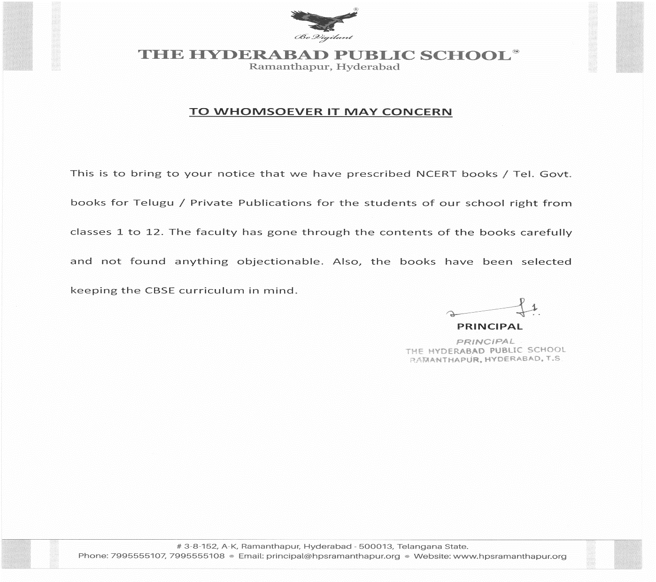
- As per the section (2.4.9) of Affiliation bye-laws, information with regard to fees for each class.

17. Period of affiliation.Till Mar. 2024
18. Academic calendar of the school

(March 2019 to March 2020)

CLASSES I TO VIII
Periodic Test I : July 20th To July 26th, 2019
Half Yearly : Sep 11th To Sep 20th, 2019
Periodic Test II : Dec 02nd To Dec 07th ,2019
Yearly Examination : Feb 18th To Feb 29th, 2020

CLASS IX
Pre Mid Term : July 20th To July 26th, 2019
Mid Term : Sep 11th To Sep 20th, 2019
Post Mid Term : Dec 02nd To Dec 07th, 2019
Yearly Examination : Feb 01st To Feb 10th, 2020

CLASS X
Unit Test : June 24th To June 29th, 2019
Pre Mid Term : July 20th To July 26th, 2019
Mid Term : Sep 11th To Sep 20th, 2019
Post Mid Term : Dec 02nd To Dec 07th, 2019
Practice Exam - I : Jan 02nd To Jan 11st , 2020
Practice Exam – II : Jan 27th To Feb 03rd, 2020

CLASS XI
Unit Test : July 20th To July 26th, 2019
Term I : Sep 11th To Sep 20th, 2019
Term II : Nov 28th To Dec 07th,2019
Term III : Feb 01st To Feb 10th, 2020

CLASS XII
Unit Test : June 24th To June 29th,2019
Unit Test : July 20th To July 26th, 2019
Term I : Sep 11th To Sep 20th, 2019
Pre Board I : Nov 28th To Dec 07th, 2019
Pre Board II : Jan 02nd To Jan 11th, 2020

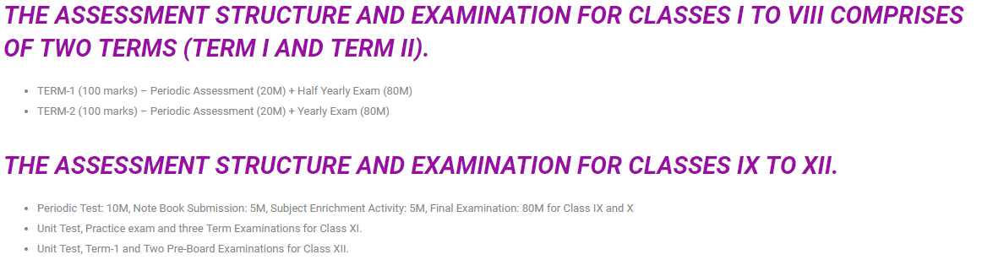

February 2019
Sun | Mon | Tue | Wed | Thu | Fri | Sat
 |  |  |  |  | 1 | 2
3 | 4 | 5 | 6 | 7 | 8 | 9
10 | 11 | 12 | 13 | 14 | 15 | 16
17 | 18 | 19 | 20  Annual examinations I – VIII begin | 21 | 22  Annual Result – classes IX,XI | 23
24 | 25  New Academic Year 2019-2020 begins classes X,XII | 26 | 27  Last exam for classes I, II | 28

March 2019
Sun | Mon | Tue | Wed | Thu | Fri | Sat
 |  |  |  |  | 1  Last exam for classes  III - VIII | 2
3 | 4  Maha Shivaratri - Holiday | 5  ROAS Primary | 6 | 7 | 8  ROAS  Classes  VI - VIII | 9
10 | 11 | 12  Annual Results  Classes  I - VIII | 13 | 14 New Academic Year  2019–2020  begins classes II - VIII | 15 | 16
17 | 18  Orientation session  for Class I parents | 19 | 20 | 21  Holi - Holiday | 22 | 23
24 | 25 | 26 | 27 | 28 | 29 | 30
31

April 2019
Sun | Mon | Tue | Wed | Thu | Fri | Sat
 | 1 | 2 | 3 Greeting card competition classes I, II | 4 Greeting card competition  Classes  III - V | 5  Babu Jagjivan Ram’s B’Day  Holiday | 6  Ugadi – Holiday
7 | 8 | 9 | 10 | 11 | 12 | 13
14  Dr BR  Ambedkar’s B’Day  Sri Rama Navami | 15  Summer vacation begins | 16 | 17 | 18 | 19  Good Friday | 20
21 | 22 | 23 | 24 | 25 | 26 | 27
28 | 29 | 30

May 2019
Sun | Mon | Tue | Wed | Thu | Fri | Sat
 |  |  | 1  May Day - Holiday | 2 | 3 | 4
5 | 6 | 7 | 8 | 9 | 10 | 11
12 | 13 | 14 | 15 | 16 | 17 | 18  Buddha Purnima- Holiday
19 | 20 | 21 | 22 | 23 | 24 | 25
26 | 27 | 28 | 29 | 30 | 31

June 2019
Sun | Mon | Tue | Wed | Thu | Fri | Sat
 |  |  |  |  |  | 1
2  Telangana Formation Day | 3 | 4 | 5  Id-ul-Fitr  Holiday | 6 | 7  School reopens for classes X, XII | 8
9  Boarders to Report | 10  School reopens after summer vacation for classes I to IX | 11 | 12 | 13 | 14 | 15
16 | 17  Orientation for class XI | 18 | 19  Fancy Dress competition Classes I, II | 20  Fancy Dress competition Classes III, IV, V | 21  Graduation Ceremony | 22
23 | 24  Unit Test begins – Classes X, XII - P - 1 | 25  P - 2 | 26  P - 3 | 27  P - 4 | 28  P - 5 | 29  P - 6
30

July 2019
Sun | Mon | Tue | Wed | Thu | Fri | Sat
 | 1 | 2 | 3 ROAS Classes X, XII  PTM  3 pm – 4 pm  Music competition classes I, II | 4  Inter House  Music competition classes III - V | 5 | 6  Inter House Music Competition – SSW
7 | 8 | 9 | 10 | 11 | 12 | 13  Investiture Ceremony
14 | 15 | 16 | 17 | 18 | 19 | 20  PT-1/Pre –Mid Term/ UT begins  P – 1
21 | 22  P – 2 | 23  P - 3 | 24  P - 4 | 25  P - 5 | 26  P – 6 | 27
28 | 29  Bonalu – Holiday | 30  ROAS Classes I – V  PTM  2 pm – 3pm | 31  ROAS Classes VI – XII  PTM –IX - XII  3 pm – 4pm  English Elocution class I

August 2019
Sun | Mon | Tue | Wed | Thu | Fri | Sat
 |  |  |  | 1  English Elocution classes I, II, III  PTM  VI – VIII  3 pm -4pm | 2  Inter House English Debate classes IV,V | 3  Inter House English Debate SSW
4 | 5 | 6 | 7 | 8  School Exhibition | 9  Vara Lakshmi Vratam – Holiday | 10  Holiday
11 | 12  Bakrid - Holiday | 13 | 14 | 15  Independence Day  Raksha Bandhan | 16 | 17
18 | 19 | 20 | 21 | 22 | 23 | 24  Janmashtami Holiday
25 | 26 | 27 | 28  Hindi Recitation classes I - III | 29  Hindi Recitation classes IV, V | 30 | 31

September 2019
Sun | Mon | Tue | Wed | Thu | Fri | Sat
1 | 2  Ganesh Chaturthi - Holiday | 3 | 4 | 5  Teachers’ Day  Hand writing competition classes I – V | 6 | 7  Inter House Hindi Debate SSW
8 | 9  Telugu Bhasha Dinotsavam | 10  Moharrum – Holiday | 11  Mid Term/  Term I/ Half-yearly begins  P-1 | 12  Ganesh Immersion - Holiday | 13  Mid Term/Term I/ Half-yearly  P-2 | 14  Hindi Divas  Mid Term/  Term I/ Half-yearly  P-3
15 | 16  Mid Term/  Term I/ Half-yearly  P-4 | 17 | 18  Mid Term  /Term I/ Half-yearly  P-5 | 19 | 20  Mid Term/  Term I/ Half-yearly  P-6 | 21
22 | 23 | 24 | 25  ROAS  I – V  PTM  2 pm-3pm | 26  ROAS  VI– XII  PTM  3pm-4pm | 27 | 28  Bathukamma  Dussehra Vacation begins
29 | 30

October 2019
Sun | Mon | Tue | Wed | Thu | Fri | Sat
 |  | 1 | 2  Gandhi Jayanthi | 3 | 4 | 5
6  Durgashtami | 7  Mahar  navami | 8  Vijaya Dasami | 9  Boarders to report | 10  School reopens after Dussehra break | 11 | 12  Working day
13 | 14 | 15 | 16  Telugu Recitation classes I - III | 17  Telugu Elocution classes IV, V | 18 | 19  Inter House Telugu Debate  SSW
20 | 21 | 22 | 23 | 24  Local Excursion  Primary | 25  Local Excursion  SSW  Primary - Holiday | 26  Naraka Chaturdasi – Holiday
27  Diwali | 28  Holiday | 29 | 30  Inter House Quiz competition  Classes I&II | 31  Inter House Quiz competition  Classes III – V

November 2019
Sun | Mon | Tue | Wed | Thu | Fri |  |  | Sat
 |  |  |  |  | 1 |  |  | 2  Inter House Quiz competition SSW
3 | 4 | 5 | 6  Spell vocab  Classes I, II | 7  Spell vocab  Classes  III - V | 8 |  |  | 9
10  Milad-Un – Nabi - Holiday | 11 | 12  Guru Nanak Jayanthi – Holiday | 13 | 14  Childrens’ Day  Art competition  Primary | 15 |  |  | 16  Cross Country
17 | 18 | 19 | 20 | 21 | 22 |  |  | 23  Annual Sports Day
24 | 25 | 26 | 27 | 28  Term- II/  Pre – Board –I  Class XI, XII  P-1 | 29 |  |  | 30  P – 2
December 2019
Sun | Mon | Tue | Wed | Thu |  | Fri | Sat
1 | 2  P – 3  PT2/Post Mid Term begins P-1 | 3  PT2/Post Mid Term  P-2 | 4  P – 4 PT2/Post Mid Term  P-3 | 5  PT2/Post Mid Term  P-4 |  | 6  P – 5  PT2/Post Mid Term  P-5 | 7  P – 6  PT2/Post Mid Term  P-6
8 | 9 | 10 | 11 | 12 |  | 13 | 14  ROAS  Classes  I – XII  PTM
15 | 16 | 17 | 18  Story Telling competition classes I, II & III | 19  Dramatisation IV, V |  | 20 | 21
22 | 23 | 24  Winter vacation begins | 25  Christmas | 26  Boxing Day |  | 27 | 28
29 | 30 | 31

January 2020
Sun | Mon | Tue | Wed | Thu | Fri | Sat
 |  |  | 1  New Year 2020  Boarders to report | 2 School reopens after Winter vacation  Practice exam I - class X,  Pre – Board -II  Class XII begins  P - 1 | 3 | 4  P - 2
5 | 6  P - 3 | 7 | 8  Dance competition  I & II  P – 4 | 9  Extempore  III - V | 10  P - 5 | 11  P - 6
12 | 13 Rangoli/clay modelling competition III – V  P - 6 | 14  Sankranthi vacation begins  Bhogi | 15  Makara Sankranthi | 16  Kanumu | 17 | 18
19  Boarders to report | 20  ROAS  Practice exam – class X  Pre board II – class XII  PTM  School reopens after Sankranti vacation | 21 | 22 | 23 | 24 | 25
26  Republic Day | 27  Practice Exam II Class X begins  P – 1 | 28 | 29  P - 2 | 30 | 31  P - 3

February 2020
Sun | Mon | Tue | Wed | Thu | Fri | Sat
1
Annual Examination – Classes IX, XI begins
P – 1
P – 4(Practice Exam)

2 | 3  P - 5  Annual exam P - 2 | 4 | 5  Annual exam P – 3 | 6 | 7  Annual exam P – 4 | 8  Annual exam  P - 5
9 | 10  Annual exam P - 6 | 11 | 12 | 13  ROAS  Class IX, X. XI  Farewell  Hostel Day | 14 | 15
16 | 17 | 18  Annual Examination – Classes I _ VIII begins  P - 1 | 19  Annual Result – classes IX, XI | 20  P - 2 | 21  Maha Sivaratri – Holiday | 22
23 | 24 New Academic Year 2020 – 21 begins  Classes X, XII  P - 3  P - 3 | 25  P - 4 | 26 | 27  P - 5 | 28 | 29  P – 6

March 2020
Sun | Mon | Tue | Wed | Thu | Fri | Sat
1 | 2 | 3 | 4 | 5 | 6 | 7  ROAS Classes I - VIII
8 | 9  Holi Holiday | 10 | 11 | 12 | 13 | 14  Annual Result  Classes I - VIII
15 | 16 New Academic Year 2020 – 21 begins classes I – VIII | 17 | 18 | 19 | 20 | 21
22 | 23 | 24 | 25  Ugadi  Holiday | 26 | 27 | 28
29 | 30 | 31

19. Details of Teacher training
- WORKSHOPS
AFS workshop was conducted on 12th March 2019. AFS-Intercultural Learning Workshop for students was conducted in the Assembly Hall to bring awareness about the importance of knowing different cultures which would benefit when they go to that particular country for their higher studies. The topic for the workshop was ‘Sustainable Development’.
American Field Service conducted AFS Intercultural Learning Workshop for the teachers on 13th March to explain the importance of Student Exchange Programmes. The resource person Mrs. Saritha presented a presentation explaining the need and importance of intercultural learning.
Univariety conducted a workshop on 30th March 2019 and the topic was ‘Workshop on Parenting’ for class 10 students. The challenges faced by the parents and the need of good parenting were discussed in the workshop. The workshop also helped to sensitize the students that not only students, parents also face challenges in bringing up their children especially in the present generation.
Vice Principal Mrs. Kiran Panjwani attended interaction programme with Principals in Hyderabad on 19th May, 2019 at DPS Nacharam .the resource person was Mr.Biswajith Saha-Director–Skill Education and Training.
TATA Class Edge subject wise training workshops were conducted on 4th June, 2019.
ICRTC workshop was held on 6th June, 2019.
Mrs.E.Priscilla, Mrs. Arunasree and Mrs. Keerthi have attended a two day ICRTC workshop at Bangalore from 29th to 30th April, 2019. The facilitator was Mr. Ravindran- Director of Educational Psychology. was conducted in the senior school wing for all the staff members on 6th June, 2019.
Students of classes 8th 9th and 10th attended a demo session on martial arts presented by ‘Indo Kendo Rennai’
The trainers displayed different Martial Art techniques to defend themselves from their enemies. The masters even invited our students onto the diars to give a tryout of their observation.
Mr. Srikanth , from the computer department attended a one day workshop on Python conducted by CBSE at Nagole Institute of Technology on 22nd June;
2019.Mrs. Sreelatha also attended a one day workshop at Gokaraju Rangaraju Engineering College, conducted by IIT Mumbai in collaboration with CBSE.
Mrs. B Swarnalatha attended a workshop on 3rd July, 2019 on Accountancy of Meridian School, Banjara Hills.

